* Open notepad application
* Save an empty file as blockchain.txt in the location where the python scripts are saved

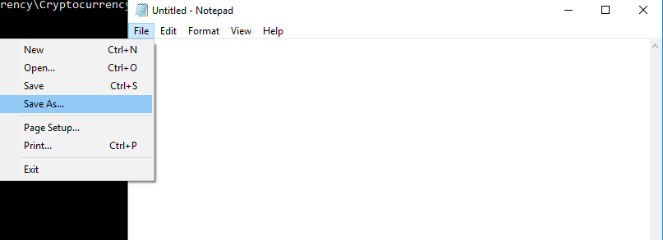

* Save an empty file as transactions.txt in the location where the python scripts are saved



* Open two PowerShell windows (side by side)

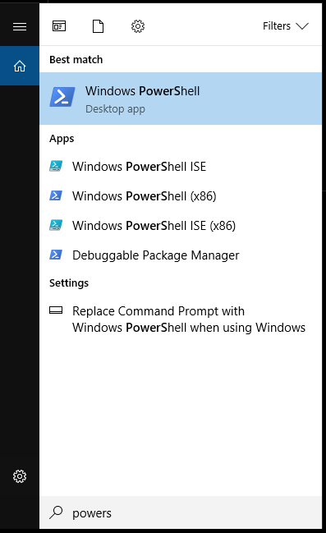

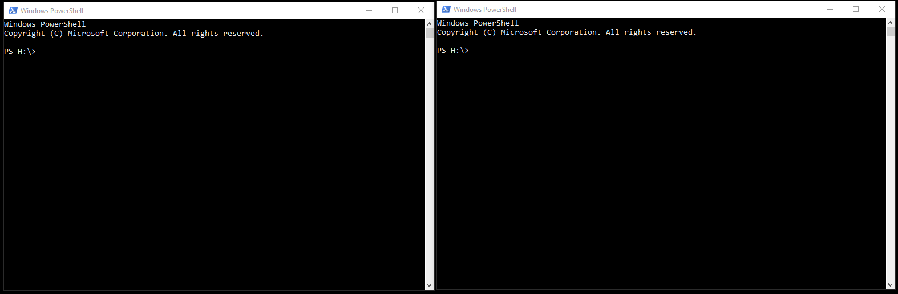

* In the **both PowerShell windows** change directory to where the python scripts are saved in local computer

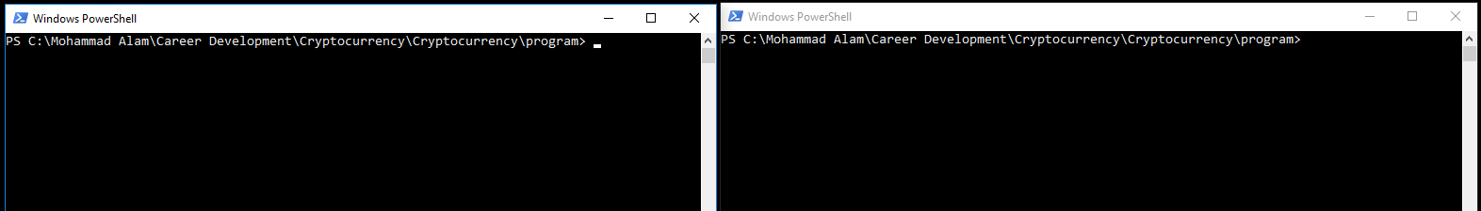

* Type “python –version” in PowerShell to check Python version

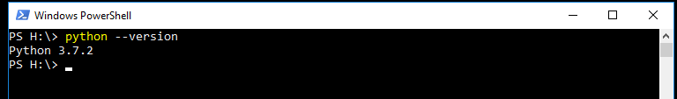

* In the **right PowerShell window** type “python mining.py”. Notice that the shell asking for input whether to look for new transaction

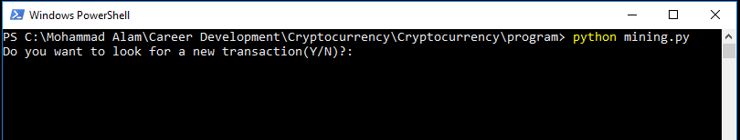

* Press Y and Enter. Notice that no new transaction detected (because the transactions.txt file is empty). Leave the program running

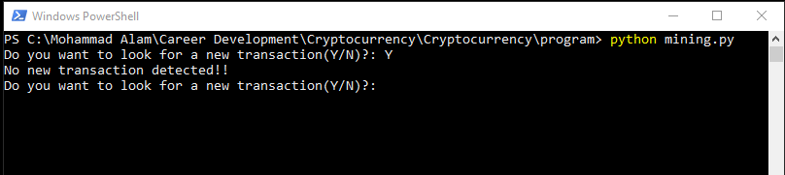

* Verify that the first hash code for block index 0 is saved in blockchain.txt file

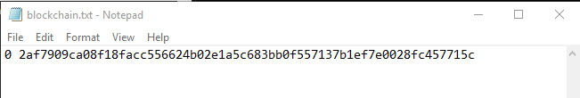

* In the **left PowerShell window** type “python transactions.py”

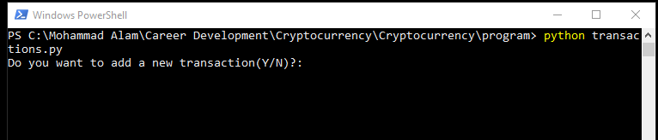

* The transactions.py script is executed and asking for user input
* Type Y and press enter

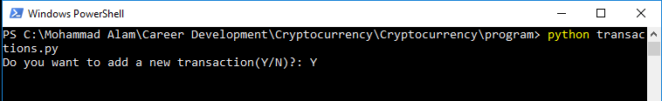

* The command shell is prompting for transaction details. Insert transaction details as follows

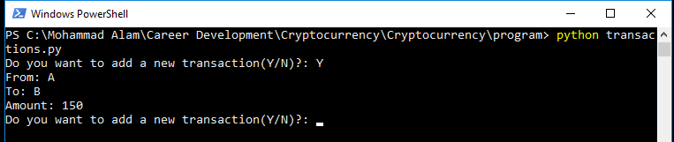

* Open the transactions.txt file and verify that the latest transaction has been recorded there

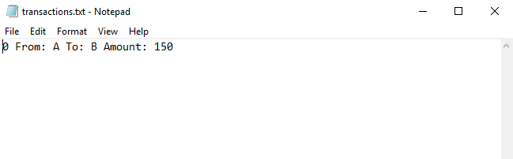

* Press Y and Enter to enter another transaction

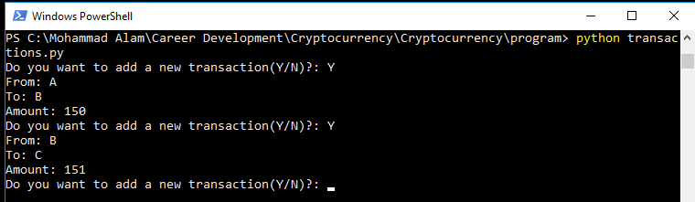

* Open the transactions.txt file and verify the new entry

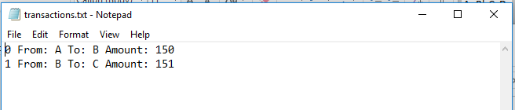

* Now you have two transactions in the transactions.txt file
* Keep the transactions.py script running in the left PowerShell window. Notice that the mining.py script is also running in the right PowerShell window

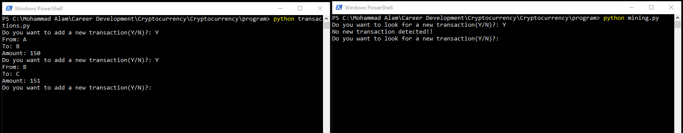

* In the **right PowerShell window** press Y and Enter

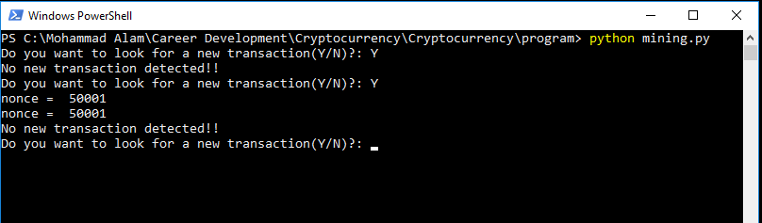

Notice that two nonce values (corresponding to each transaction is printed) until there is no new transaction left in the transactions.txt file.

* Verify that in the blockchain.txt file the hash bytes and nonce are recorded in block indexes 1 and 2

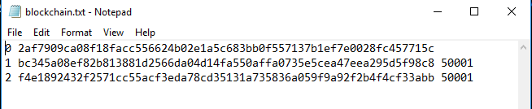

* Enter a new transaction in the left PowerShell window (leave the program running)

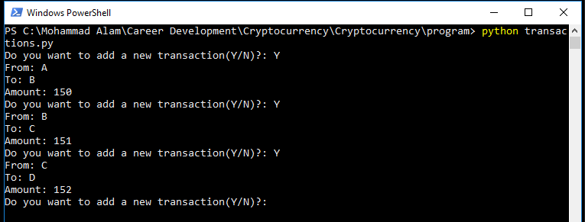

* Verify that the new transaction has been added to the transactions.txt file

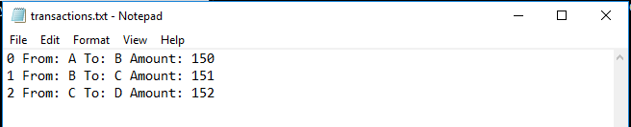

* In the right PowerShell window press Y and Enter. This will pick up the latest transaction and calculate its nonce

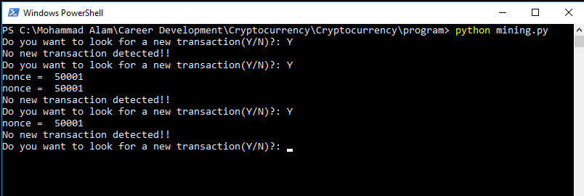+

* Verify that a new block has been added in the blockchain file

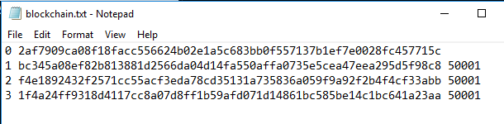

Keep adding transactions (left PowerShell window), calculate nonce (right PowerShell window) and verify that the transactions and blocks are added in the transactions.txt and blockchain.py files, respectively.

Press N and Enter in both PowerShell windows to stop the programs

